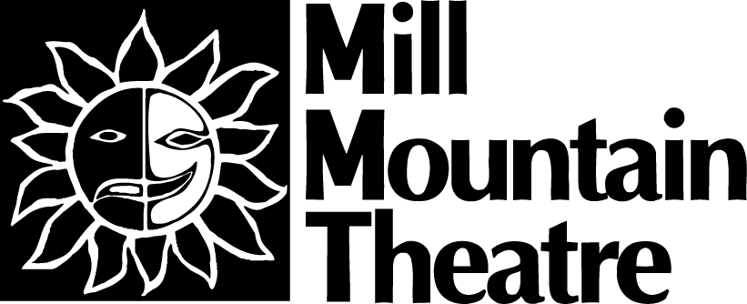 News Release
1 Market Square, S.E.
Second Floor
Roanoke, VA 24011
www.millmountain.org

FOR IMMEDIATE RELEASE

Contact:
Lindsay Mady, Public Relations Coordinator
lmady@millmountain.org
PHONE:(540) 224-1255

MILL MOUNTAIN THEATRE PRESENTS NO SHAME 100

Roanoke, VA – February 24, 2006 – Mill Mountain Theatre and Underground Roanoke present a one night only special event on the Trinkle Main Stage. Saturday March 25, 2006 will be a celebration of the 100th performance of NO SHAME THEATRE at Mill Mountain Theatre. This Best of No Shame event will showcase not only the favorite pieces from the late night venue over the past year, but MMT is expecting guest appearances by No Shamers from around the country. All past Best Of No Shame events on the Waldron Stage have sold out, so this very special Best of No Shame will be on the Trinkle Main Stage.

Jeff Goode, one of the original three founders of No Shame Theatre and currently the Director of No Shame Los Angeles will be flying in to Roanoke to help celebrate the 100th performance. Jeff is a professional playwright and working writer for the big and small screen in Hollywood. This is also the 20th Anniversary of No Shame’s original launch from the back of Todd Ristau’s, Director of MMT’s No Shame Theatre, pick up truck in the parking lot of the University of Iowa’s theatre department.

NO SHAME 100 is designed to give those who have not quite been able to stay up until 11pm a chance to participate in the No Shame fun! All the pieces are chosen from past No Shames, and they are selected by audience response at No Shame performances, by the online polls at the No Shame Roanoke message board (go to www.noshame.org), and the raw intuition of Todd Ristau and other regular No Shamers. For those who have never been to No Shame Theatre, NO SHAME 100 is a chance to sample audience tested and approved samplings from the anything goes late night theatre experiment. Also, audience members, writers, and performers of No Shame Theatre will not want to miss this celebration of the success they had a part in creating.

NO SHAME 100
Saturday March 25, 2006
8pm
Trinkle Main Stage
$8
www.millmountain.org or (540) 342-5740

Underground Roanoke is also hosting another event. A free public reading of Jeff Goode’s internationally known play, THE EIGHT: Reindeer Monologues will take place on Friday March 24, 2006 at 8pm on the Waldron Stage. THE EIGHT was originally developed and performed at No Shame Theatre in Chicago and later published by Baker’s Plays. The reading will feature local No Shame regulars and will be directed by Todd Ristau. THE EIGHT is now produced at 20+ theatres every Christmas and has been translated into several languages. This play deals with adult themes and contains strong language and mature content.

THE EIGHT: Reindeer Monologues
Friday March 24, 2006
8pm
Waldron Stage
FREE

*All Underground Roanoke events are sponsored by the Roanoke Times.

###

