Murder by Midnight: A Director’s Book
Kyle Banquer
Directing 1
Dr. Bianchini
5/5/15

I) First Impressions
See following looseleaf. Sorry for its crumpled state, it got stuck underneath my laptop.

II) Research
a) Playwright: Jeff Goode
“Jeff Goode is a director, producer and the author of over 50 plays, musicals and children's shows, including The Eight: Reindeer Monologues, Marley's Ghost, the award-winning Love Loves a Pornographer, and the cult hit Poona the Fuckdog and other plays for children.
His published scripts include The Misadventures of Dick Piston, Hotel Detective, The UBU Plays (a children's trilogy based on the Jarry classic), and the Dickensian Christmas hit Marley's Ghost, for which he was named Broadway Play Publishing's Playwright of the Year.
He is the winner of both the Los Angeles Drama Critics Circle Award for Distinguished Achievement in Writing, and the Backstage Garland Award for Excellence in Playwriting.
Raised in Iowa, and now living in Los Angeles, Jeff has written television pilots for Fox, UPN, USA Networks, Canal Plus, and two for MTV, including the pilot for Undressed. For the Disney Channel, he created and executive produced the animated television series American Dragon: Jake Long.
Jeff is a co-founder of No Shame Theatre, and founding artistic director of No Shame Los Angeles.
He is currently a visiting professor of playwriting at Hollins University in Roanoke, Virginia, and playwright-in-chief with SkyPilot Theatre Company in Los Angeles.” (from Jeffgoode.com/bio)

b) List of other Plays:
The Elf (1987)
Dead Panther Cabaret (1989)
Waiting On Godot (1990)
Escape From Eldorado (1990)
Dead Poets (1990)
Rumpelstiltskin (1990)
Who Killed Cock Robin (1991)
Narcissus & Echo (1992)
UBU: a play for children (1994)
Ring Cycle! the Musical (1994)
THE EIGHT: Reindeer Monologues (1994)
Ubu Two: Ubu in America (1995)
Elephans (1995)
Larry and the Werewolf (1995)
Dracula Rides Again (1995)
Portrait of the Virgin Mary Feeding the Dinosaurs (1996)
Lesbian's Last Pizza (1996)
Princess Gray and the Black & White Knights (1996)
In Real Life (1996)
Ubu Three: Where's Ubu? (1997)
The Death of Dick Piston (1998)
Poona the Fuckdog and other plays for children (1999)
Prague-nosis! (2001)
The UnXmas Story (2001)
Anger Box (2003)
Don Quixote and the Black Knight (2003)
Marley's Ghost (2003)
Romeo & Julius [Caesar] (2004)
Jolly Jack Junior: the Buccaneer's Bairn (2005)
Your Swash Is Unbuckled (2007)
Ham/thello (2007)
Murder By Midnight (2007)
Love Loves a Pornographer (2007)
Seven Santas (2007)
Lear's Labour's Lost (2008)
Cosmetic Perjury (2008)
Savin’ Up for Saturday Night (2009)
Yes, Svetlana, There is a Grandfather Frost (2009)
Prosthesis: Murder! (2010)
The Emancipation of Alabaster McGill (2011)
Æsopera (2012)

c) Any information about this play in performance (reviews, etc)
Premiered in 2007 at the Reality Aside Theatre, NYC. No non-amateur materials could be found.
- Select links to other amateur performances:
CCNY One Act Festival, 2013—believe it or not, it’s far too ridiculous. Too much added in, but some bits were good. It feels like William Shatner is playing Piston.
https://www.youtube.com/watch?v=0padgn77ATs

- From Ross Sheppard One Act Festival. I love the way they staged the monologue. If I had the ability to film a detective scene via video and project it while Dick walks around, it would work out perfectly. Feels too serious, though, sans sound effects. I’m looking for a happy medium between these two.
https://www.youtube.com/watch?v=gVu4I9xUTc4
d) Critical articles about the play, playwright, or time period.
The era in which Murder by Midnight takes place is not specifically stated. The only indications of the era are references to Baghdad’s murder rate and Xeroxing copies. The Xerox copier as we know it was introduced in 1959, which sets the play at some point after that date. Baghdad, on the other hand, did not become inherently violent outside of wartime until the 2003 American occupation of the city.
With that all in mind, the question of when the play takes does not become any less murky. For the sake of simplicity, I decided to stage the play in a broadly modern era. In doing so, I would not have to worry about the contradiction of dates, since Xeroxing, Baghdadi violence, and the noir genre itself all fit under this umbrella categorization.
Film noir, as a style, extended through the early 1940’s to the late 1950’s. The phrase itself is a cinematic term used primarily to describe stylized crime dramas that tended to emphasize cynical attitudes and sexual motivations. The world of film noir is just like its French namesake: black film. The movies were gritty, filled with shadows, and ambiguous. Even the good guy seemed bad at times. The stereotypical hardboiled detective of film noir originated out of the cynicism within the crime fiction that accompanied America’s Great Depression.
Because of the ambiguity that exists in categorizing films as noir by genre, most films are considered noir in regards to their styles of videography. Most film noir incorporated and emphasized “low-key lighting and unbalanced compositions.”
Roger Ebert, Film critic at the Chicago Sun-Times, describes Film Noir far more effectively than I ever could, saying that Film noir is . . .
1. A French term meaning "black film," or film of the night, inspired by the Series Noir, a line of cheap paperbacks that translated hard-boiled American crime authors and found a popular audience in France.
2. A movie which at no time misleads you into thinking there is going to be a happy ending.
3. Locations that reek of the night, of shadows, of alleys, of the back doors of fancy places, of apartment buildings with a high turnover rate, of taxi drivers and bartenders who have seen it all.
4. Cigarettes. Everybody in film noir is always smoking, as if to say, "On top of everything else, I've been assigned to get through three packs today." The best smoking movie of all time is "Out of the Past," in which Robert Mitchum andKirk Douglas smoke furiously at each other. At one point, Mitchum enters a room, Douglas extends a pack and says, "Cigarette?" and Mitchum, holding up his hand, says, "Smoking."
(Note—smoking is too hard to stage. As nice as it would be for character, it’s too complicated to use fake smoking in such a simplistic presentation)
5. Women who would just as soon kill you as love you, and vice versa.
6. For women: low necklines, floppy hats, mascara, lipstick, dressing rooms, boudoirs, calling the doorman by his first name, high heels, red dresses, elbowlength gloves, mixing drinks, having gangsters as boyfriends, having soft spots for alcoholic private eyes, wanting a lot of someone else's women, sprawling dead on the floor with every limb meticulously arranged and every hair in place.
7. For men: fedoras, suits and ties, shabby residential hotels with a neon sign blinking through the window, buying yourself a drink out of the office bottle, cars with running boards, all-night diners, protecting kids who shouldn't be playing with the big guys, being on first-name terms with homicide cops, knowing a lot of people whose descriptions end in "ies," such as bookies, newsies, junkies, alkys, jockeys and cabbies.
8. Movies either shot in black and white, or feeling like they were.
9. Relationships in which love is only the final flop card in the poker game of death.
10. The most American film genre, because no society could have created a world so filled with doom, fate, fear and betrayal, unless it were essentially naive and optimistic.”

The main takeaway from Film Noir is the shared theme most instances of the genre employ. Everyone involved in the genre is looking for a way to get out of this gritty, depressing world. The play should incorporate this theme so as to better portray the genre.

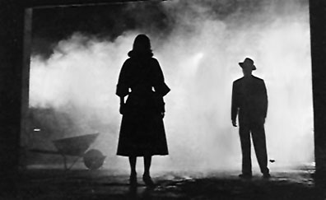
Scene from The Big Combo (1955), acts as genre’s ‘go-to’ image—everybody’s seen this before.

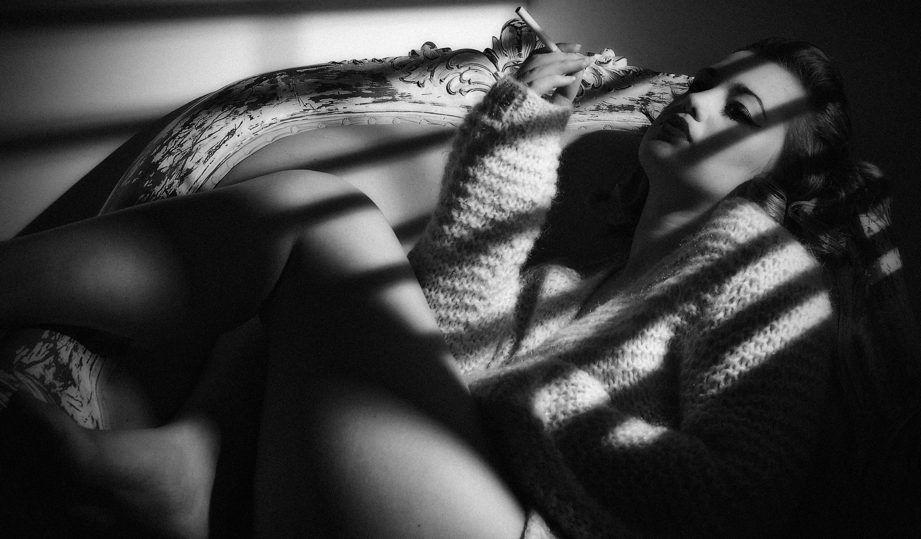
(Depiction of Femme Fatale persona commonly found within film noir)

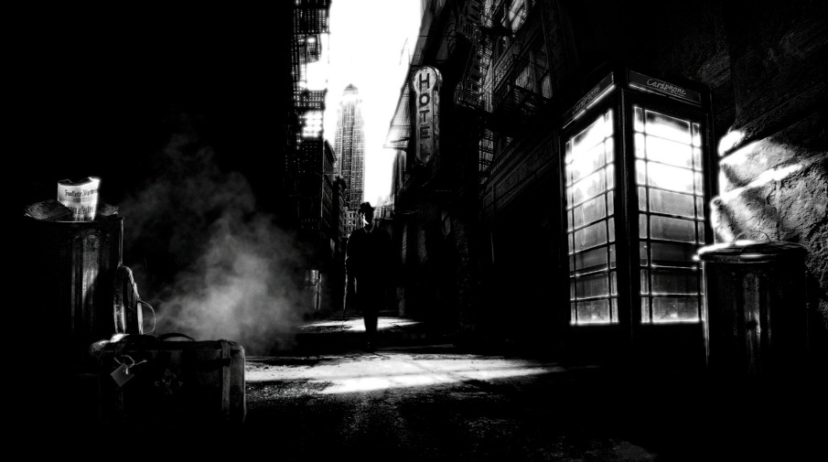
(illustrated depiction of stereotypical noir landscape)

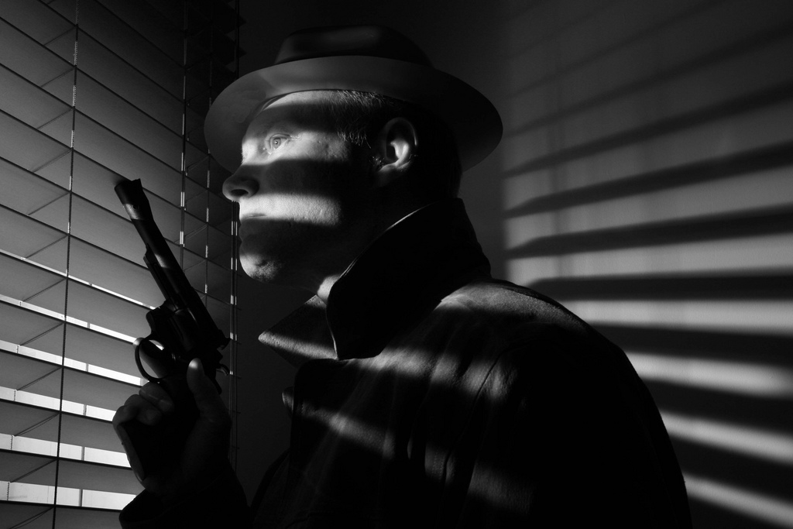
(Depiction of film noir’s hard-boiled detective)
e) Research about the time period of the play AND any references made by text

Because of the play’s ambiguous time period for reasons previously established, this section will primarily concern only textual references that aren’t obvious:
- The presence of the woman in the towel pays homage to “Double Indemnity,” a classic noir film that introduced Barbara Stanwyck in a similar fashion (see following page) In the movie, Fred MacMurrary walks into a room, looks up a grand staircase, only to find her in a towel.
- A hotel detective was a plain clothed person engaged to monitor the security of a hotel and investigate various security or rule violations. In other words, he was the precursor to the modern security guard. They were often featured throughout noir, and were commonly referred to as “house dicks.” This reveals Piston’s name to be punny. Ha.
- Champagne and oysters are a traditional faire for fancy formal occasions. No idea why, but they are.

3) World of the play
This is a play about _______.
Make a list. It should be long. Put everything down you can think of. After looking at it a few times, try to identify your five strongest themes from the list and underline those five things.
See attached loose-leaf reg. world of the play.

4) Spine
What is the play about on a super-objective level? Who is the protagonist? What do they want? Remember, spine statements are broad statements—they are not reiterations of plot. A spine is a universal that the protagonist is searching for, something all audience members can relate to or identify with.

Murder by Midnight shares a spine similar to many other productions within the noir genre: “to get out.” Everything about this play concerns every character’s desire to escape from the terrible environment they find themselves in. Dick Piston wants to escape his Friday night duties so that they may become “Somebody else’s Saturday morning problems,” and during the case, he just wants it to be resolved. The woman wants to escape the guilt of her husband’s murder and the complications of her affair with the bellhop. The bellhop wants to escape the lies he has been caught up in as well—he has been used by the woman, and fittingly wants to achieve closure. In a sense, all characters encounter what they have been driving toward throughout the course of the play; The bellhop and woman escape the gritty reality of their noir world through death, therein by escaping their preceding complications and commitments, while Dick Piston escapes by no longer having any commitments to the case, since all major players are dead, and therefore has annulled his responsibilities.

5) structure
Identify the structure of the play including the following moments: status quo, inciting incident, collision factor, crisis (x3), recognition scene, obligatory scene, climax, denouement/new status quo.
See pink markings in script

6) Character Breakdown
Write a short breakdown of each character that would be suitable to distribute at an audition. Names of characters, rough ages, and key characteristics should be included.
After this, take a page for each character and write down everything you know about the character. Write down every piece of information that is revealed about the character, either because they say it about themselves, or others say it about them. Identify the main objectives for the character throughout the play.

See the three following loose leaf pages.

7)beats
organize the script according to beats. Identify each beat in the script and give it a name. Note the exact line or moment where the beat changes.

There are 12 beats within this play, with each of them being marked by a shaded, black bar within the attached script.

8) letter to a designer
write a 1page(single spaced) letter to your set/light/costume/sound designer. (you can choose to write to one designer specifically, or address all four, or a combination of the four. ) Describe what you want the design of the play to look and feel like,. This letter is a passionate and cogent statement about the play and your sense of the spine, the world of the play, and your staging concept.

See following page.

Designers,

First and foremost, thank you for hypothetically agreeing to aid me in putting on this hypothetically full-fledged production of Murder by Midnight. Dick Piston’s world is nearly the exact world that one would find in Film Noir’s classic flicks—Casablanca, The Maltese Falcon, Chinatown, Double Indemnity… the list goes on. Like all of the movies within the genre, the world within Murder by Midnight is dark and gritty, filled ambiguity that is further complicated by the continuing contrast of light of shadow, of black and white. Nothing is as it seems, and everyone has ulterior motives. Most importantly, everyone lives in a world of increasing danger, and everyone is trying his or her best to get to some place better.
Stylistically, Film Noir consisted of black and white film highlighted by low-key lighting and the contrast of shadow. On the stage, such binary color is nearly impossible to achieve, and while the same contrast between light and shadow could possibly be achieved, a larger focus should be put on making the play look gritty, jaded, and harsh. Everything about how awful the world of this play is should be present within its designed elements. It needs to be worn and tired. The contrast through which the parody will occur will be executed by the characters and how they react to this environment.
In terms of sound and light, the nature of the genre needs to be addressed within. The sound designer and myself have already collaborated on a few effects that will make the show seem as if it were a radio drama, just like the old “ABC mystery hour” programs, but without the horror elements. The sounds should be cliché as well; the music should sound like it could have been the theme to Chinatown, and the sound effects should be realistic and authentic, not synthetic. The lights should be able to reflect Piston’s soliloqual moments, which are integral to making this show seem like it is a scene right out of one of those noir movies. Similarly, the lights, sounds, and props should be able to keep up with the action in the play, which represents the characters’ attempts to get out of this crappy noir world. The props, however, have the added burden of reflecting the reality of this gritty world—in other words, no guns with flags that pop out which say ‘bang!’
The set should be real and slightly worn, as if it is tired of this gritty world as well, no matter how tired it may be, it should still hold the capacity to function fully. It should not exceed anything that is mentioned in the script. Naturally, there needs to be a bunch of office furniture—a desk in particular—and a door should be present as well. Like Dick, the desk should be the center of attention, and his interactions with the Woman should be a struggle for said attention. The costumes should entail this same mentality as well, save for the Woman’s towel (I mean, there’s only so much you can do with a towel). The bellhop should be the only one who looks polished, because such presentation is pretty much a part of his job description.

In closing, I am looking forward to seeing what we are able to come up with while collaborating in the design of this production. Just remember—real, gritty, functional, and escape inducing.

Best,
Mr. Big Time Director Guy
9) Rehearsal reflection
Write a 1-2 page summation of the rehearsal process. How have rehearsals progressed? What did you work on first? What challenged you? What came easily? This is a time for your own reflection on the process.

See next page.

Rehearsal was, for me at least, an absolute joy. There was nothing more enjoyable than spending time with actors who were willing to help my vision reach its potential. In the beginning, I had trouble getting everyone to embrace the caricatures of the genre we were playing. As time went on, however, the ridiculousness of their parody became known. Christian was perhaps the most pleasurable to work with because of the growth he displayed. He went from trying to be badass to trying to be over-the-top ridiculous after I had brought up the nature of his character in a role playing game that we both play, and I’d like to think that the discussion paid off. A lot of the antics were his idea, and they worked perfectly—the dropping of the tray and the excess of noise it made, the use of the ‘Christian Scream’ in order to describe his craziness, and the manner in which he interacted with Dick were all a result of him becoming the batshit crazy bellhop I needed him to be. There were some suggestions I had to decline—a shouting match between him and Dick and wearing Olivia’s towel as a cape (obvious problems with that one) were obviously no-go’s. However, in the end, he did a damned good job, was a true asset to the production, and I could not have been more satisfied or proud of the work he did.
Matt was just as excellent as well. His improvisational experience really showed, and he was quite good at coming up with means to portray his cluelessness on the fly. He was able to develop his character to the same extent with much less overbearing guidance, and he understood the nature of Dick within the play perfectly. The man (dick, I mean) is an idiot, and spends a good chunk of time during the play trying to prove that he is not. Matt was great because he was able to flesh out his character in regards to my vision without me having to pry it out of him.
Olivia was probably the toughest actor to work with, and that is through no fault of her own. The part of the woman is inherently difficult due to its foreignness. From what I know of modern society, woman aren’t as Femme Fatale as they were in the noir movies, and Olivia had a hard time portraying her character through that lens at first. After emphasizing the teasingly seductive nature of the Woman, (much to my displeasure, it felt pretty awkward to talk about it, and talking about it was almost as much of a feat for me as it was for Olivia to play this character), however, Olivia progressed toward playing the character well. After every rehearsal, I’d ask her for more and more seductive behavior—I wanted her character to be overcome with a desire for Dick, which in turn hid a desire to clear her own name. Eventually, Olivia cut most of the cutsey crap, which her seduction had been coming off as, and embraced it. It was over the top and ridiculous, and worked perfectly.
The other hiccup in the rehearsal process was that of pace. The first time we ran the show off book, it came in at about 30 minutes, which is excessively long for a ten-minute play. I had the actors then do a speed read, followed by a running of the scene again. Lo and behold, it only took about 20 this time. Through consistent emphasis on speeding up, we were able to get the show at about 12 minutes—roughly one minute per page, minus sound cues and pauses. The actors and I then identified the moments that should be taken slow, and talked about why, and incorporated them into our final performance. I think the pace ended up being just right.
One other struggle was sound and the space. Due to Goldor, we did not get to rehearse until the week before. Even then, we did not rehearse with teched sound cues until two days before performance. Part of that is my fault for putting too many technical things into a barebones process, but it worked out really well in the end. The sound, as well, was a pain because I didn’t have a means to figure out its volume until we moved into the space, and the fact that my laptop’s fan often overpowers my speakers didn’t help much. In the Black box, it took a good chunk of time to calibrate the volume so that Matt wasn’t shouting over the music during his monologue (it’s really hard to hear the sound levels within the space from the booth!).
The door used in the set was also a problem, simply because in order to open it, one has to forcefully lift it into its frame or else it scrapes along its base, getting stuck.
The biggest challenge for me was confidence. By nature, I’m a pretty pessimistic person, and that pessimism tends to manifest in all the things I try to do. The fact that everyone else in the class talked about how well their plays were coming along made me uncertain as well, because I couldn’t match their enthusiasm. I have to give credit to Nick Palm for helping me overcome that barrier, though. He listened to my ideas and thoughts, spoke his mind, and most importantly, repeatedly told me that the show didn’t suck as much as I thought it did. Of course, I didn’t fully believe it until I saw the audience laugh endlessly over all of the things that I had forgotten were funny. I probably would have put far less effort into this project if I didn’t have the deadline in front of me and Nick behind me with a cattle prod. I can’t thank him enough, and only wish I was able to help him out as much as he helped me.
I also had the help of a dedicated cast that I bonded with to a large extent. The show would be meaningless if they didn’t approve of both what I was attempting to do and of how I directed. If it weren’t for them, it would have literally collapsed. I owe some thanks to Stewart as well, and through interacting with him constantly, have a newfound appreciation for how hard he works and for the hard work he has to constantly and almost unappreciatively do. His aid with props and tech was invaluable.
Overall, the process felt a lot like putting together a good sized jigsaw puzzle—the pieces were there, and there was a sense of what the final product was going to be. I’m just lucky that I didn’t lose any pieces underneath the couch.

